**Tutorial – 1**

1. Write a C program to print “Hello World” on the output screen.

| namespace _24SOECE13043_Dharmraj_sodha.LAB1 {  internal class Q1  {  public static void Main(string[] a)  {  Console.WriteLine("Hello world");  }  } } |
| --- |

**Output:**



2 : Design your profile page as given below.

| namespace _24SOECE13043_Dharmraj_sodha.LAB1 {  internal class Q2  {  public static void Main(string[] a)  {  Console.WriteLine(@"  Name: Dharmraj sodha  DOB: kiyu batavu   Address:Jamnager,  India  City: Jamnagar  Pincode:361001  State: Gujarat  Country: India  Mail: Mymail@mail.com");  }  } } |
| --- |

**Output:**

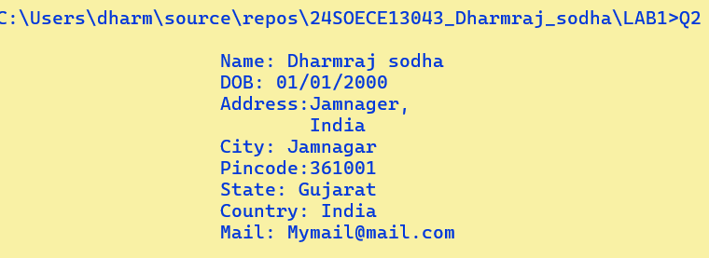

3 : Find out whether the given number is odd or even.

| **namespace _24SOECE13043_Dharmraj_sodha.LAB1 {  internal class Q3  {  public static void Main(string[] a)  {  Console.Write("Enter Number: ");  int number = Convert.ToInt32(Console.ReadLine());  if (number % 2 == 0  Console.WriteLine($"{number} is even");  else  Console.WriteLine($"{number} is odd");  }  } }** |
| --- |

**Output:**

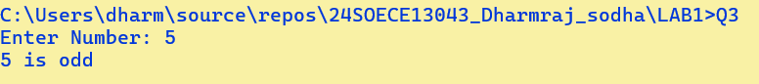

4 : Rearrange the given code to correct the program. The resultant program will be to input a number and print whether the given number is odd or even.

| using System; namespace ConsoleApplication1  {  class Q4   {  static void Main(string[] args)  {  int x;  Console.WriteLine("Enter Number : ");  string str = Console.ReadLine();  x = Convert.ToInt32(str);  if (x % 2 == 0)  Console.WriteLine("Number is Odd");  else  Console.WriteLine("Number is Even");  Console.Read();  }  } } |
| --- |

**Output:**

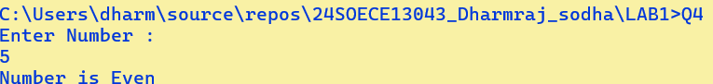

5 : Write output of the program. Also write comment for each line for the following code.

| using System; // Importing the System namespace for basic input/output operations  // Declaring a namespace to group related classes  namespace _24SOECE13043_Dharmraj_sodha.LAB1  {  // Class definition  class Q5  {  // Main method - entry point of the program  static void Main(string[] args)  {  int n, fact = 1; // Declare variables: n for input number, fact to store factorial result  // Prompt user to enter a number  Console.WriteLine("Enter Number : ");    // Read user input as string  string str = Console.ReadLine();  // Convert the input string to an integer  n = Convert.ToInt32(str);  // Calculate factorial using a for loop  for (int i = 1; i <= n; i++)  {  fact = fact * i; // Multiply current value of fact by i  }  // Display the calculated factorial  Console.WriteLine("Factorial : {0}", fact);  // Keep the console window open until a key is pressed  Console.Read();  }  }  } |
| --- |

**Output:**

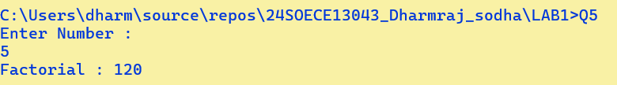

6.Write missing statement to get the desired output.

| using System;  namespace _24SOECE13043_Dharmraj_sodha.LAB1  {   class Q6   {   static void Main(string[] args)   {  int a, b, c, result;   Console.Write("Enter Number 1: ");   string str = Console.ReadLine();   a = Convert.ToInt32(str);     Console.Write("Enter Number 2 : ");   str = Console.ReadLine();   b = Convert.ToInt32(str);     Console.Write("Enter Number 3 : ");  str = Console.ReadLine()  c = Convert.ToInt32(str);  result = Sum(a, b, c);   Console.Write($"Sum of above numbers is: {result}");  Console.Read();   }   static int Sum(int x, int y, int z)   {   int res;   res = x + y + z;   return res;   }   }  } |
| --- |

**Output:**

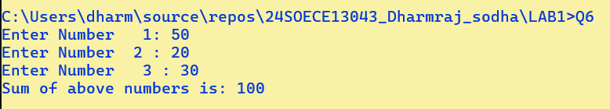

7 : Predict and write the output of the given code.

| namespace _24SOECE13043_Dharmraj_sodha.LAB1 {  internal class Q7  {  public static void Main(string[] a)  {  int num1, res, i;   Console.WriteLine("Enter a number");  num1 = Convert.ToInt32(Console.ReadLine());    i = 1; //Initialization   //Check whether condition matches or not  while (i <= 10)  {  res = num1 * i;  Console.WriteLine("{0} x {1} = {2}", num1, i, res);    i++; //Increment by one  }  Console.ReadLine();  }  } } |
| --- |

**Output:**

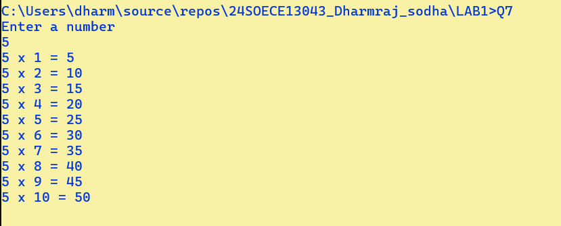

8 Write a program to convert given name in upper characters.

INPUT : John F Kennedy

OUTPUT: JOHN F KENNEDY

| using System; namespace _24SOECE13043_Dharmraj_sodha.LAB1 {  internal class Q8  {  public static void Main(string[] a)  {  Console.Write("Enter your String: ");  string str = Console.ReadLine();  //A -65to90 and a-97to122  foreach (char c in str)  {  int unicode = c;  if (unicode >= 97 && unicode <= 122)  {  unicode -= 32;  Console.Write(((char)unicode));  }  else  {  Console.Write(((char)unicode));  }  }    }  } } |
| --- |

**Output:**



9 Write a Program to convert given name in toggle case.

INPUT : JoHn F kEnNedy

OUTPUT: jOhN f KeNneDY

| using System; namespace _24SOECE13043_Dharmraj_sodha.LAB1 {  internal class Q9  {  public static void Main(string[] a)  {  Console.Write("Enter your String: ");  string str = Console.ReadLine();  //A -65to90 and a-97to122  foreach (char c in str)  {  int unicode = c;  if (unicode >= 97 && unicode <= 122)  {  unicode -= 32;    }  else if (unicode >= 65 && unicode <= 90)  {   unicode += 32;   }  Console.Write(((char)unicode));    }   }  } } |
| --- |

**Output:**

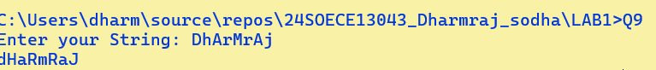

10 Write a Program which accepts mobile no as a string from the user and converts the last 5 digits into X.

INPUT : 1234567890

OUTPUT: 12345XXXXX

| using System;  namespace _24SOECE13043_Dharmraj_sodha.LAB1 {  internal class Q10  {  public static void Main(string[] a)  {  Console.Write("Enter your Phone number: ");  string str = Console.ReadLine();   string[] myArray = new string[str.Length];  for (int i = 0; i < str.Length; i++)  {  myArray[i] = str[i].ToString();  if (i >= 5) {  myArray[i] = "X";  }  }  Console.WriteLine(string.Join("",myArray));  }  } } |
| --- |

**Output:**



11 Write a Program which accepts name and gender from the user. Here, gender may have only 1 character, M or F.

Based on the gender prefix the name Mr. & Ms.

NAME : Ms. Hillary Clinton

GENDER : F

| using System;  namespace _24SOECE13043_Dharmraj_sodha.LAB1 {  internal class Q11  {  public static void Main(string[] a)  {  Console.Write("Enter your Good Name: ");  string name = Console.ReadLine();  Console.WriteLine($"Name: {name}");  name = name.ToLower();   if (!(name.StartsWith("mr") || name.StartsWith("ms")))  Console.WriteLine("Gender: not mention");  if (name.StartsWith("mr"))  Console.WriteLine("Gender: Male");  else  Console.WriteLine("Gender: Famale");    }  } } |
| --- |

**Output:**

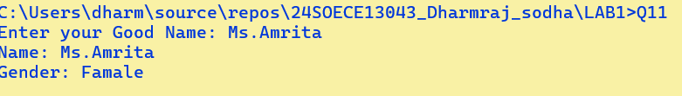

12 Write a Program which accepts name from the user and prints the same

INPUT : Winston Churchill

OUTPUT: Winston Churchill

| using System;  namespace _24SOECE13043_Dharmraj_sodha.LAB1 {  internal class Q12  {  public static void Main(string[] a)  { Console.Write("INPUT: ");  string str = Console.ReadLine();  Console.WriteLine($"Output: {str}");   }  } } |
| --- |

**Output:**

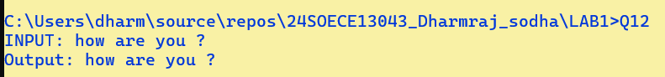

13 Write a Program to prints the following series

0 1 1 2 3 5 8 13 21 34 55

| using System; namespace _24SOECE13043_Dharmraj_sodha.LAB1 {  internal class Q13  {  public static void Main(string[] ar)  {  int a = 0,b = 1;  Console.Write($"{a} {b} ");  while(b != 55)  {  Console.Write($"{b = a + (a = b)} ");  }  }  } } |
| --- |

**Output:**



14 Write a Program which accepts no from the user and print the same in words.

INPUT : 98732

OUTPUT: Nine Eight Seven Three Two

| using System; using System.Collections.Generic;  namespace _24SOECE13043_Dharmraj_sodha.LAB1 {  internal class Q14  {  public static void Main(string[] args)  {   Console.Write("Enter a number: ");  string input = Console.ReadLine();   Dictionary<char, string> digitWords = new Dictionary<char, string>()  {  { '0', "Zero" },  { '1', "One" },  { '2', "Two" },  { '3', "Three" },  { '4', "Four" },  { '5', "Five" },  { '6', "Six" },  { '7', "Seven" },  { '8', "Eight" },  { '9', "Nine" }  };   if (!long.TryParse(input, out _))  {  Console.WriteLine("Invalid input! Please enter digits only.");  return;  }   foreach (char digit in input)  {  Console.Write(digitWords[digit] + " ");  }   Console.WriteLine()  }   } } |
| --- |

**Output:**

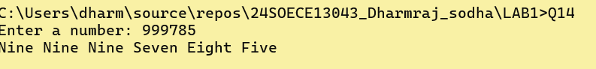

15 Write a Program to check whether the given no is Armstrong no or not.

| using System; using System.Numerics; namespace _24SOECE13043_Dharmraj_sodha.LAB1 {  internal class Q15  {  public static void Main(string[] args)  {  int number=0, len=0,sum=0,clone;  Console.Write("Enter a decimal number: ");  clone = number = Convert.ToInt32( Console.ReadLine());  len = number.ToString().Length;   while (number > 0)  {  sum += Convert.ToInt32(Math.Pow((number % 10), len));  number /= 10;  }  Console.WriteLine($"{clone} is{(clone==sum ? "":" not")} armstrong ");  }  } } |
| --- |

**Output:**

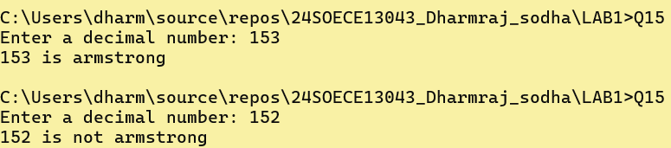

16 Write a program to display a pattern like a right angle triangle using an asterisk

| using System; namespace _24SOECE13043_Dharmraj_sodha.LAB1 {  internal class Q16  {  public static void Main(string[] args)  { for (int i = 1; i <= 5; i++)  {  for (int j = 1; j <= i; j++)  {  System.Console.Write('*');  }  System.Console.WriteLine();  }  }  } } |
| --- |

**Output:**

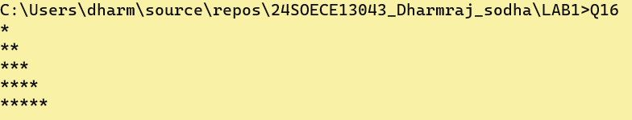

17. Write a Program to generate following output.

| using System; namespace _24SOECE13043_Dharmraj_sodha.LAB1 {  internal class Q17  {  public static void Main(string[] args)  {  for (int i = 1; i < 5; i++)  {  for (int j = 1; j <= i; j++)  {  System.Console.Write(j+" ");  }  System.Console.WriteLine();  }  }  } } |
| --- |

**Output:**

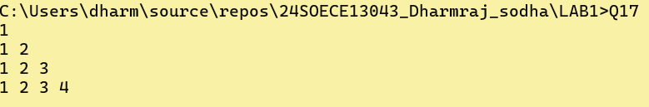

18 Write a program to make such a pattern like a right angle triangle with the number increased by 1.

| using System; namespace _24SOECE13043_Dharmraj_sodha.LAB1 {  internal class Q18  {  public static void Main(string[] args)  {  int m = 1;  for (int i = 1; i < 5; i++)  {  for (int j = 1; j <= i; j++)  {  System.Console.Write(m++ + " ");  }  System.Console.WriteLine();  }  }  } } |
| --- |

**Output:**

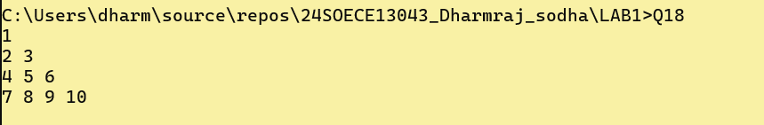

**19. Write a program to make such a pattern as a pyramid with an asterisk.**

| using System; namespace _24SOECE13043_Dharmraj_sodha.LAB1 {  internal class Q19  {  public static void Main(string[] args)  {  int m = 3;  for (int i = 1; i < 5 ; i++)  {  for (int j = m; j >= 1; j--)  {   System.Console.Write(" ");  }  m--;  for (int j = 1; j <= i; j++)  {  System.Console.Write("* ");  }  System.Console.WriteLine();  }  }  } } |
| --- |

**Output:**

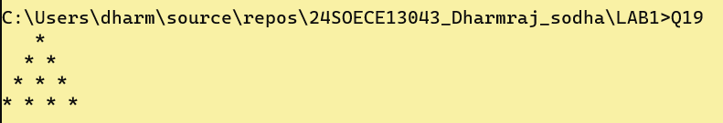

20. Write a program to make a pyramid pattern with numbers increased by 1.

| using System; namespace _24SOECE13043_Dharmraj_sodha.LAB1 {  internal class Q20  {  public static void Main(string[] args)  {  int m = 3;  int a = 1;  for (int i = 1; i < 5; i++)  {  for (int j = m; j >= 1; j--)  {  System.Console.Write(" ");  }  m--;  for (int j = 1; j <= i; j++)  {  System.Console.Write(a+" ");  a++;  }  System.Console.WriteLine();  }  }  } } |
| --- |

**Output:**

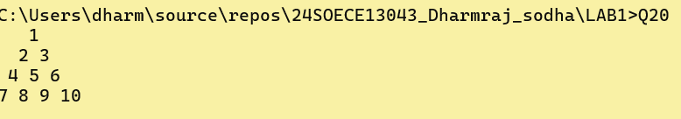

21. Write a program to find the sum of the series 5 +55 + 555 + 5555 + .. n terms.   
Test Data :  
Input the number of terms : 4

Input number : 5  
*Expected Output* :  
5 + 55 + 555 + 5555  
The Sum is : 6170

| using System;   namespace _24SOECE13043_Dharmraj_sodha.LAB1 {  internal class Q21  {  public static void Main(string[] args)  {    int sum=0,n=0;  string og, t;  try  {  Console.Write("Enter N term : ");  n = Convert.ToInt32(Console.ReadLine());  Console.Write("Input number: ");  t = og = Console.ReadLine();  while (n>0)  {  sum += Convert.ToInt32(t);  t += og;  n--;  }  Console.WriteLine(sum);   } catch {  Console.WriteLine("Invalid input! Please enter a valid number.");  return;  }   }  } } |
| --- |

**Output:**

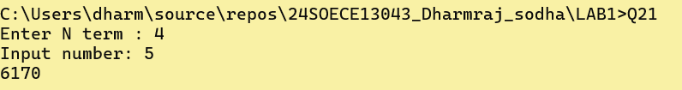

22. Write a program to display a pattern like a diamond.

| using System; namespace _24SOECE13043_Dharmraj_sodha.LAB1 {  internal class Q22  {  public static void Main()  {  int n = 5;  for (int i = 1; i <= 2 * n - 1; i++)  {  int spaces = Math.Abs(n - i);  int stars = 2 * (n - spaces) - 1;   Console.Write(new string(' ', spaces));  Console.WriteLine(new string('*', stars));  }  }  } } |
| --- |

**Output:**

